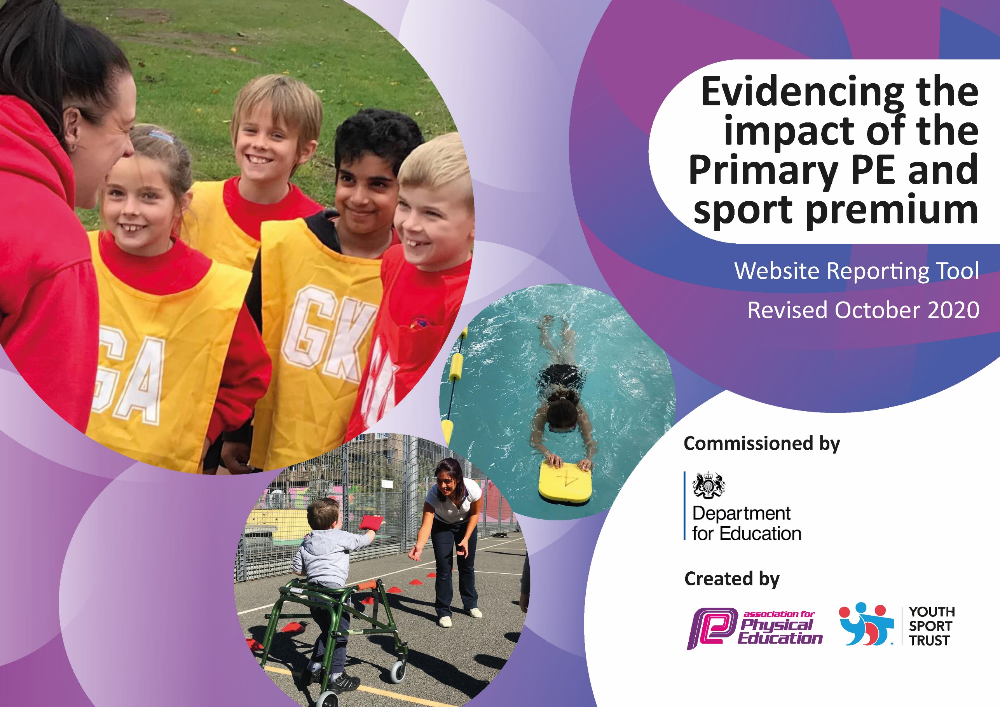
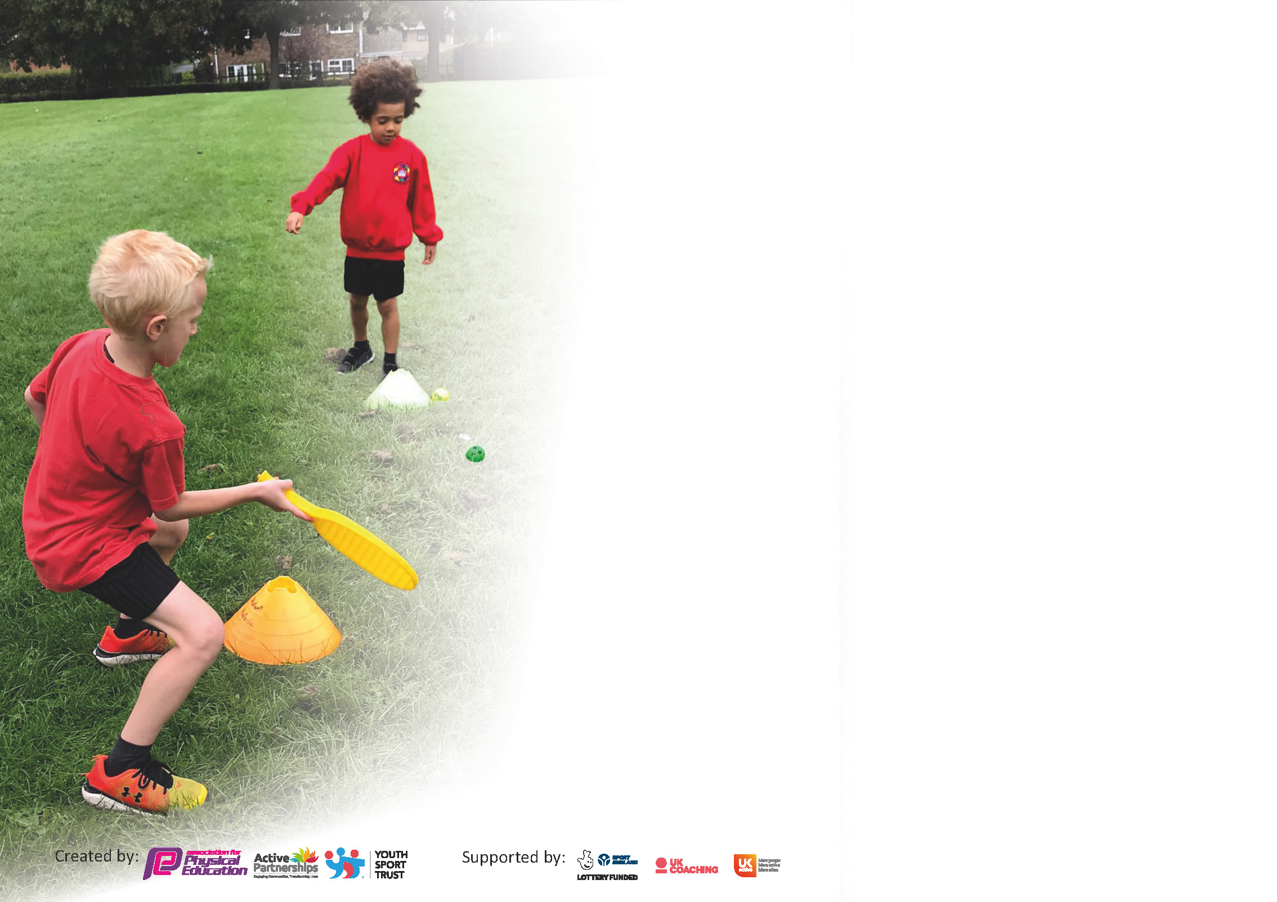

It is important that your grant is used effectively and based on school need. The Education Inspection Framework (Ofsted 2019 p64) makes clear there will be a focus on ‘whether leaders and those responsible for governors all understand their respective roles and perform these in a way that enhances the effectiveness of the school’.

Under the Quality of Education criteria (p41) inspectors consider the extent to which schools can articulate their curriculum (INTENT), construct their curriculum (IMPLEMENTATION) and demonstrate the outcomes which result (IMPACT).

To assist schools with common transferable language this template has been developed to utilise the same three headings which should make your plans easily transferable between working documents.

Schools must use the funding to make additional and sustainable improvements to the quality of Physical Education, School Sport and Physical Activity (PESSPA) they offer. This means that you should use
the Primary PE and sport premium to:

- Develop or add to the PESSPA activities that your school already offer
- Build capacity and capability within the school to ensure that improvements made now will benefit pupils joining the school in future years

Please visit gov.uk for the revised DfE guidance including the 5 key indicators across which schools should demonstrate an improvement. This document will help you to review your
provision and to report your spend. DfE encourages schools to use this template as an effective way of meeting the reporting requirements of the Primary PE and sport premium.

We recommend you start by reflecting on the impact of current provision and reviewing the previous spend.

Schools are required to publish details of how they spend this funding as well as on the impact it has on pupils’ PE and sport participation and attainment by the end of the summer term or by 31st July 2021 at the latest.

** In the case of any under-spend from 2019/20 which has been carried over this must be used and published by 31st March 2021.

We recommend regularly updating the table and publishing it on your website throughout the year. This evidences your ongoing self-evaluation of how you are using the funding to secure maximum, sustainable impact. Final copy must
be posted on your website by the end of the academic year and no later than the 31st July 2021. To see an example of how to complete the table please click HERE.
Created by: Supported by:

Please note: Although there has been considerable disruption in 2020 it is important that you publish details on your website of how you spend the funding - this is a legal requirement.
Support for review and reflection - considering the 5 key indicators from DfE, what development needs are a priority for your setting and your pupils now and why? Use the space below to reflect on previous spend and key achievements and areas for development.

N.B. In this section you should refer to any adjustments you might have made due to Covid-19 and how these will influence further improvement.

Key achievements to date until July 21-22: | Areas for further improvement and baseline evidence of need for 22-23:
Active travel implemented through school (travel tracker) | PE leader and BM to search for and apply for a playground development grant to promote physical literacy across school. Sports hall developments to include a physical literacy link to nurture grow flourish signage.
Re-introduction of sports leaders – main focus is developing their leadership skills during fitness Fridays | Promote breakfast club with a link to sport/health - wellbeing to extend our offer of a broader experience in sporting activities for all.
After school clubs are now being offered to KS1 and KS2 | Continuation of CAS framework – Further CPD for LSA’s regarding maximising active playtime opportunities / continued CPD for teaching staff regarding active learning
Staff feedback received from the implementation of PE PRO. Feedback is positive and is proving to icrease teacher confidence in PE delivery | Re-integration of sports teams (pending south Bradford games plan)
Curriculum resources continue to be audited. New resources are ordered where necessary including equipment to facilitate the curriculum delivery during directed play times by the coaches. | Experience days for every year group (rock climbing, water sports etc)
Implementation of CAS framework. Audit complete and staff training underway to promote a culture of physical activity throughout the school day. | Amount of clubs offered. Teachers now delivering however there is a need to look into external providers to provide a broad offer of sporting club opportunities.
Assessment data from a central platform in use by all teachers
Number of lunch time coaches employed has increased (x2) delivery targets curriculum strands

Did you carry forward an underspend from 2019-20 academic year into the current academic year? YES/NO * Delete as applicable

If YES you must complete the following section
If NO, the following section is not applicable to you

If any funding from the academic year 2019/20 has been carried over you MUST complete the following section. Any carried over funding MUST be spent by 31 March 2021.
Academic Year: September 22/23 | Total fund carried over: £ | Date Updated:6/2/22
What Key indicator(s) are you going to focus on? |  |  |  | Total Carry Over Funding:
 |  |  |  | £
Intent | Implementation |  | Impact
Your school focus should be clear how you want to impact on your pupils. | Make sure your actions to achieve are linked to your intentions: | Carry over funding allocated: | Evidence of impact: How can you measure the impact on your pupils; you may have focussed on the difference that PE, SS & PA have made to pupils re-engagement with school. What has changed?: | Sustainability and suggested next steps and how does this link with the key indicators on which you are focussing this academic year?:

Meeting national curriculum requirements for swimming and water safety.  N.B Complete this section to your best ability. For example, you might have practised safe self-rescue techniques on dry land. | Year 3 attending an intensive Two-week swimming course. 1 hour per day. Efficacy of this will be evident June 2022
What percentage of your current Year 6 cohort swim competently, confidently, and proficiently over a distance of at least 25 metres?  N.B. Even though your pupils may swim in another year please report on their attainment on leaving primary school at the end of the summer term 2021. | Not taken place due to covid-19
What percentage of your current Year 6 cohort use a range of strokes effectively [for example, front crawl, backstroke, and breaststroke]? | Not taken place due to covid-19
What percentage of your current Year 6 cohort perform safe self-rescue in different water-based situations? | Not taken place due to covid-19
Schools can choose to use the Primary PE and sport premium to provide additional provision for swimming, but this must be for activity over and above the national curriculum requirements. Have you used it in this way? | No

Action Plan and Budget Tracking
Capture your intended annual spend against the 5 key indicators. Clarify the success criteria and evidence of impact that you intend to measure to evaluate for pupils today and for the future.

Academic Year: 2022/23 | Total fund allocated: £19000 | Date Updated:6.2.22

Key indicator 1: The engagement of all pupils in regular physical activity – Chief Medical Officers guidelines recommend that primary school pupils undertake at least 30 minutes of physical activity a day in school |  |  |  | Percentage of total allocation:
 |  |  |  | 42%
Intent | Implementation |  | Impact
Your school focus should be clear what you want the pupils to know and be able to do and about  what they need to learn and to  consolidate through practice: | Make sure your actions to achieve are linked to your intentions: | Funding allocated: | Evidence of impact: what do pupils now know and what can they now do? What has changed? | Sustainability and suggested next steps:
To provide a lunch time sports coach with a focus on play-directed curriculum coverage. Sports coach deployed across both KS1 and KS2. | Sport Coaches hired from (AUT 1). Sports coach attended an initial meeting with the PE leader to identify areas of the curriculum that can be covered through directed play to increase physical activity for all and support curriculum coverage. Regular update meetings are held between the PE leader and the coach, amendments are made where necessary. | £7600 | The amount of play directed physical activity children engage in has increased outside of curriculum time. All year groups are developing fundamental skills needed for success in sporting activities. | Identification of children in need of further skill development or health and well-being support
Playtime equipment to be purchased to promote independent physical activity. | Equipment purchased. PE and playtime equipment separated to monitor effectiveness and sustainability. | £350 | Playtime equipment continues to be used effectively however sustainability us poor as equipment has to continually replaced. | CPD of playtime LSA’s on effective play opportunities and demonstrating use of equipment. Continued coaching children of respectful use of equipment.

Key indicator 2: The profile of PESSPA being raised across the school as a tool for whole school improvement |  |  |  | Percentage of total allocation:
 |  |  |  | 0%
Intent | Implementation |  | Impact
Your school focus should be clear what you want the pupils to know and be able to do and about  what they need to learn and to  consolidate through practice: | Make sure your actions to achieve are linked to your intentions: | Funding allocated: | Evidence of impact: what do pupils now know and what can they now do? What has changed?: | Sustainability and suggested next steps:
Lead of PE to continue to meet with staff to identify children who are least active and create active plans for those children including after school and during school interventions. | PE meet with staff members to discuss children who are not attending clubs and who are below expected through our assessment tool and create a plan for those children. PE leader to develop a plan to deliver interventions to those identified at risk. | £0 | Yet to be achieved this year. Will be developed throughout 21-22 and implement in 22-23. | Staff will continue to offer a wide range of clubs for the children to experience, monitor the success of the clubs and make any changes necessary to ensure clubs are inclusive. Continue to discuss with staff and children regarding the children attending and not attending the clubs and identified as at risk.
Continue to create opportunities for KS1 to take part in clubs’ competitions as well as increased activities at break time and lunchtimes 22-23academic year | Audit and identify children who have not attended extra-curricular clubs and provide these children with a new opportunity and/or competitions Meet with KS1 teachers to agree clubs that would benefit the children Contact schools to organise fixtures and competitions. | £0 | Uptake if KS1 clubs have been average. | Promotion of KS1 clubs to be pushed more in 22-23 including variety.

Key indicator 3: Increased confidence, knowledge and skills of all staff in teaching PE and sport |  |  |  | Percentage of total allocation:
 |  |  |  | 12%
Intent | Implementation |  | Impact
Your school focus should be clear  what they need to learn and to  consolidate through practice: | Make sure your actions to achieve are linked to your intentions: | Funding | Evidence of impact: what do  changed? | Sustainability and suggested
Your school focus should be clear what you want the pupils to know and be able to do and about what they need to learn and to consolidate through practice | Make sure your actions to achieve are linked to your intentions | Funding allocated | Evidence of impact: what do pupils now know and what can they do now? What has changed? | Sustainability and suggested next steps:
Teacher to review the PE pro assessment data and target underachieving children and those at risk of obesity | PE leader to liaise with teaching staff to monitor and action where necessary into physical /health interventions | £0 | At risk children identified and targeted, increasing the likelihood of a healthy life style and physical health. | Monitor teacher confidence in assessment – further CPD to be provided where necessary
New resources and equipment to be purchased to enable a broad curriculum. PE leader to review curriculum provider suggested resources. | Resources purchased and staff made aware of what is available old and new. | £350 | Resources purchased have allowed for the full breadth of curriculum to be accessed. Knowing the equipment is available and of high quality has allowed teachers to explore new aspects of PE. | Curriculum resources to be audited at the end of the academic year. New resources to be ordered where necessary including equipment to facilitate the curriculum delivery during directed play times by the coaches.
Continued awareness of updates of PE and sport guidance. | Attended the West Yorkshire PE conference. Developments and guidance noted and considered. | £50 | PE leader aware of current and on-going guidance for PE. Developments for the curriculum have been put in place to meet the needs of our children and teacher development. | Attend the annual West Yorkshire PE leaders conference to keep up to date with latest initiatives and trends
Re-new PE curriculum provider which supports teacher's confidence as well as a focus on the fundamentals of skill development (identified as a need for child progress in PE). | PE PRO APP purchase date May 2022. PE leader currently trialling. CPD dates set for 2022/2023Improvements in delivery, teacher confidence and monitoring expected to dramatically improve. | £1,800 | All impact will be evident in the next academic year. | Monitor the progress of children's progress as well as teacher confidence following the implementation stage

Key indicator 4: Broader experience of a range of sports and activities offered to all pupils |  |  |  | Percentage of total allocation:
 |  |  |  | 46%
Intent | Implementation |  | Impact
Your school focus should be clear  what you want the pupils to know  and be able to do and about  what they need to learn and to  consolidate through practice: | Make sure your actions to  achieve are linked to your  intentions: | Funding  allocated: | Evidence of impact: what do  pupils now know and what  can they now do? What has  changed?: | Sustainability and suggested  next steps:
Experience days for every year group (rock climbing, water sports etc) | PE Leader sourcing experience days for each year group (EYFS – YR6) PE leader will ensure each year group are provided with a unique sporting/adventurous activity to attend in the summer term. | £9000 | Children will have experienced a sporting/adventurous activity not usually accessible to our children, targeting cultural capital. | PE leader to make strong links with external providers to ensure strong future relationships and opportunities for children.

Key indicator 5: Increased participation in competitive sport |  |  |  | Percentage of total allocation:
 |  |  |  | 0 %
Intent | Implementation |  | Impact
Your school focus should be clear  what you want the pupils to know  and be able to do and about  what they need to learn and to  consolidate through practice: | Make sure your actions to  achieve are linked to your  intentions: | Funding  allocated: | Evidence of impact: what do  pupils now know and what  can they now do? What has  changed?: | Sustainability and suggested  next steps:
Re-integrate back into the South Bradford School Games. South Bradford plan dependent … pending. | Competitive sport has not taken place due to Covid-19  Teachers and school staff will be deployed to delivery extra-curricular sporting activities. The goal of this will be to increase out offer of unique sporting opportunities to our children. Year groups targeted: EYFS – Yr. 6. With the breadth we will offer the opportunities for entering a variety of competitive competitions will increase. | £0 | None – due to covid-19 | PE Leader to track sporting events and submit entries.

Signed off by
Head Teacher: | Paul Urry
Date: | 6/2/22
Subject Leader: | David Kerr
Date: | 6/2/22
Governor:
Date:

