

Recruitment Pack Teacher

Contents:
- Letter from the Headteacher
- Our school
- Job Advertisement
- Job Description
- Person Specification

Introduction from the Headteacher
Dear Candidate,
Thank you for your interest in the position of class teacher at St. Stephen’s CE Primary School.
I am delighted that you have taken the opportunity to consider joining our hardworking and dedicated staff team.
St Stephen’s is a popular and thriving voluntary aided church school in the West Bowling area of Bradford where parents, staff and governors work closely together as a school family to make sure that all pupils have a positive experience and achieve their full potential.
Our ethos builds on the Church of England foundation of the school, promoting the belief that every individual has the right to be nurtured so that they can grow and flourish in their lives.
The dedicated staff team at St Stephen's provide a wide range of lessons and activities in order to enhance learning. We work hard to make sure that all our pupils, regardless of gender, class, additional support need, religion or ethnic heritage have equal access to a broad, balanced and differentiated curriculum and are provided with opportunities to develop their sense of self-worth, increase their self-esteem and grow in confidence.
Keeping our pupils safe is one of the most important aspects of our work and we take Safeguarding very seriously.
Please take the opportunity to enjoy exploring our website to find out more about our school community https://www.ststephens.bradford.sch.uk/
Visits to the school are strongly recommended and we invite all prospective candidates to make an appointment to visit our school. Please contact Louise Hurley, School Business Manager louise.hurley@ststephens.bradford.sch.uk to arrange a visit.

Please do not hesitate to get in touch if you have any questions about our school.

Mr Paul Urry
Headteacher

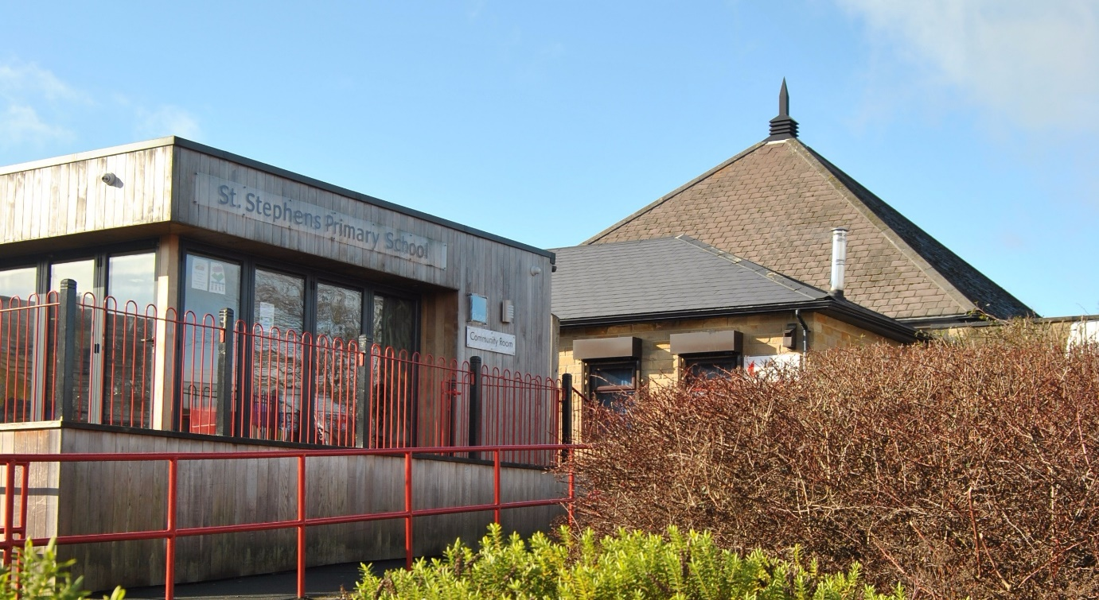

Our school
St. Stephen’s is a two-form entry primary school with a 60 place nursery based on a split site. We serve the community of West Bowling, which sits just outside the centre of Bradford.
We operate from five buildings – Nursery, Willow (EYFS & KS1), Sycamore (KS2), The Orchard (community space) and our very own standalone Digital Den.
We currently have 455 pupils on role and our pupils come from a wide variety of backgrounds with 44% of our pupils being eligible for Free School Meals.
St. Stephen’s is at the heart of the local community and partnership is our watchword.
Our school is well resourced with support staff who support learning. We are lucky to have our own woodlands team who support our most vulnerable children and those with additional needs.
To find out more about our school, please visit our school website, Facebook page and Twitter.




Job Advertisement
Teacher (Maternity Cover)
MPS
Required from 1 January 2025 for a minimum of 2 terms.
An exciting opportunity has arisen for an enthusiastic and committed teacher to join our staff team. If you have a passion for helping children reach their potential and are motivated and enthusiastic, then we encourage you to apply for this job!
St. Stephen’s Primary School is a vibrant, creative and aspirational school with a team of hard working and highly skilled staff and governors. Our pupils come from a wide range of backgrounds and abilities, they are enthusiastic learners who deserve and respond to the best.
We are seeking to appoint a teacher who has the drive and commitment to contribute to the success of our children.
We are looking for a candidate who:
- Has an honours degree or other relevant Level 6 equivalent qualification
- Has the ability to consistently deliver good / outstanding teaching that maximizes pupil progress
- Has a proven record of raising attainment through highly effective use of pupil data
- Can motivate and inspire children with high expectations and engaging opportunities within their provision
- Has ambition and is dedicated to supporting all children in their learning
- Is interested in leading a curriculum subject
We can offer:
- Positive working relationships with a motivated and hard-working staff team
- A commitment to your on-going professional development
- Children keen to learn with supportive families
- A hard-working and professional school environment
Visits to the school are strongly encouraged and individual times can be arranged by contacting Louise Hurley, School Business Manager on 01274 731698 or louise.hurley@ststephens.bradford.sch.uk.

To apply for this position, please visit our school website to download an application form https://www.ststephens.bradford.sch.uk/about-us/vacancies
Completed application forms should be returned to louise.hurley@ststephens.bradford.sch.uk
Closing Date: 27th November 2024
Shortlisted candidates will be notified in writing.
Interviews will be held week beginning 2nd December.
St. Stephen's CE Primary School is committed to safeguarding and promoting the welfare of our pupils and we expect all prospective candidates to share this commitment. All candidates are subject to an Enhanced DBS Check and recruitment checks satisfactory to the school.
Please note: CVs are not accepted for this post.

Post Title: | Teacher
Payscale: | MPS
JOB DESCRIPTION

Generic Introduction:
The following description of duties has been prepared to assist staff joining the School to understand and appreciate the work content of their post and the role they are to play in the organisation. The following points should be noted:

- Whilst every endeavour has been made to outline the main duties and responsibilities of the post, a document such as this does not permit every item to be specified in detail. This job description is not a definitive list of responsibilities but identifies key components of the role. The post holder will therefore, be required to undertake other reasonable duties commensurate with the purpose and salary level of this post.

- Employees should not refuse to undertake work, which is not specified on this form, but they should record any additional duties they are required to perform and these will be taken into account when the post is reviewed.

- The school is an Equal Opportunities Employer and requires its employees to comply with all current equality policies in terms of equal opportunity for employment and access to the school’s Services.

- The school is committed, where possible, to making any necessary reasonable adjustments to the job role and the working environment that would enable access to employment opportunities for disabled job applicants or continued employment for any employee who develops a disabling condition.

Prime Objectives of the Post:
As a Primary school teacher you will be an outstanding classroom practitioner who consistently demonstrates the highest standards of delivery. You should be fully committed to raising attainment across the whole school and across all subjects that you are required to teach. You will be acutely aware of the strategies required to achieve the highest standards within your specialist subject area/across the curriculum.
You may from time to time be required to undertake other duties commensurate with the grade and level of responsibility defined in this job description.
As a Classroom teacher you will, at all times, be mindful of, and adhere to, the Professional Standards for Teachers and the Career Stage expectations negotiated and adopted by the school at any time.
In addition, for Teachers paid on the Upper Pay Range (UPR), your achievements and contribution to an educational setting should be substantial and sustained.

Knowledge and Skills:
(See Personnel Specification)

Effort Demands:
- Will contribute to the overall ethos/work/aims of the school.

- Will appreciate and support the role of other professionals.

- Be vigilant and sensitive to any child protection/safeguarding concerns that arise, reporting any concerns to the designated officer in line with school policy and procedure.

- Will deal with any issues, immediate problems or emergencies that arise in line with school policies and procedures liaising with colleagues where necessary e.g. dealing with a sick, injured or distressed child.

environmental demands/Working Conditions:
- Will have long periods of sitting and standing

- Available to work during school hours during term time and a willingness to be flexible as may be required to attend staff meetings/training sessions outside of usual hours.

- Will have contact with members of the public/other professionals e.g. teaching staff, governors, parents/carers, community groups, local education authority, external providers etc.

- The post holder may occasionally be subjected to antisocial behaviour from members of the public/parents/site users.

- This post may include a degree of manual lifting and handling. You are expected to be aware of health and safety policies and procedures and frequently assess your ability to carry out the lifting tasks required of you.

- Report all concerns to an appropriate person.

main duties and Responsibilities:

Teaching
To teach pupils according to their individual educational needs, including the appropriate setting and marking of work to be carried out by the pupils.
Identifying effective intervention and mentoring strategies for pupils.
To mark and grade pupils work in a way which enables you to give written/verbal and diagnostic feedback and maintain records of pupils' progress and development.
To use a variety of delivery methods, which will stimulate learning appropriate to pupil needs and demands of the syllabus, for example, podcasts, interactive whiteboards etc.
Prepare pupils for internal and external assessments and examinations.
To undertake pastoral duties, supporting pupils on an individual basis through academic or personal difficulties.
Health, safety and discipline
To ensure a safe, secure and healthy environment for pupils
To manage pupil behaviour in the classroom and on school premises, and apply appropriate and effective measures in cases of misbehaviour
To actively encourage good practice with regard to punctuality, behaviour, standards of work and independent learning.
Whole school organisation and strategy
To participate in and organise extracurricular activities, such as outings, social activities and sporting events; including participation in occasional overnight visits.
To contribute to the development, implementation and evaluation of school’s policies, practices and procedures in such a way as to support the school’s values and vision.
Work with others on curriculum and/or pupil development to secure co-ordinated outcomes.
Subject to the guidance relating to Cover, supervise and teach any pupils where the person timetabled to take the class is not available to do so.
Management of staff and resources
To prepare and regularly update subject materials including researching new topic areas and writing new curriculum materials.
To supervise and support the work of classroom support, teaching assistants, trainee teachers and Early Career Teachers (ECTs)
To efficiently deploy such resources as are allocated/delegated to you.
Contribute to the recruitment, selection appointment and professional development of other teachers and support staff.
Professional Development
To under-go regular observations and participate in regular in-service training (INSET) as part of continuing professional development (CPD).
Where appropriate, to participate in arrangements for the appraisal and review of other teachers and support staff.
Participate in arrangements for your own further training and professional development and, where appropriate, that of other teachers and support staff.

Communication
To communicate with parents and carers over pupils' progress and participate in parents' evenings and whole school training events.
Working with colleagues and other relevant professionals
To liaise with other professionals, such as learning mentors, careers advisers, educational psychologists, education welfare officers etc.

Other considerations
- To be aware of and comply with policies and procedures relating to child protection; being vigilant for signs that children may be being abused and to report any such suspicions to the school’s nominated Designated Safeguarding Lead.

- To act in accordance with the Data Protection Act and maintain confidentiality at all times e.g. access to staff/student/parent and carers files.

- Be able to perform all duties and tasks with reasonable adjustments, where appropriate, in accordance with the Equality Act.

- Must be legally entitled to work in the UK.

PERSONNEL SPECIFICATION:

 | ESSENTIAL (E) /DESIRABLE (D)
Experience: | - Proven record of success as an outstanding Teacher (D)  - An understanding and demonstration of barriers to learning and how those may be overcome (E)  - Experience of managing pupil performance and intervention strategies to raise performance (E)  - Previous teaching within primary education (E)  - Experience of safeguarding and additional educational needs (E)
Qualifications/  Training: | - Honours degree or equivalent in relevant subject (E)  - Qualified Teacher Status (E)  - Professional qualification or relevant experience (E)
Knowledge/Skills | - Excellent literacy, numeracy and IT skills (E)  - Ability to communicate effectively with a range of internal and external stakeholders (E)

