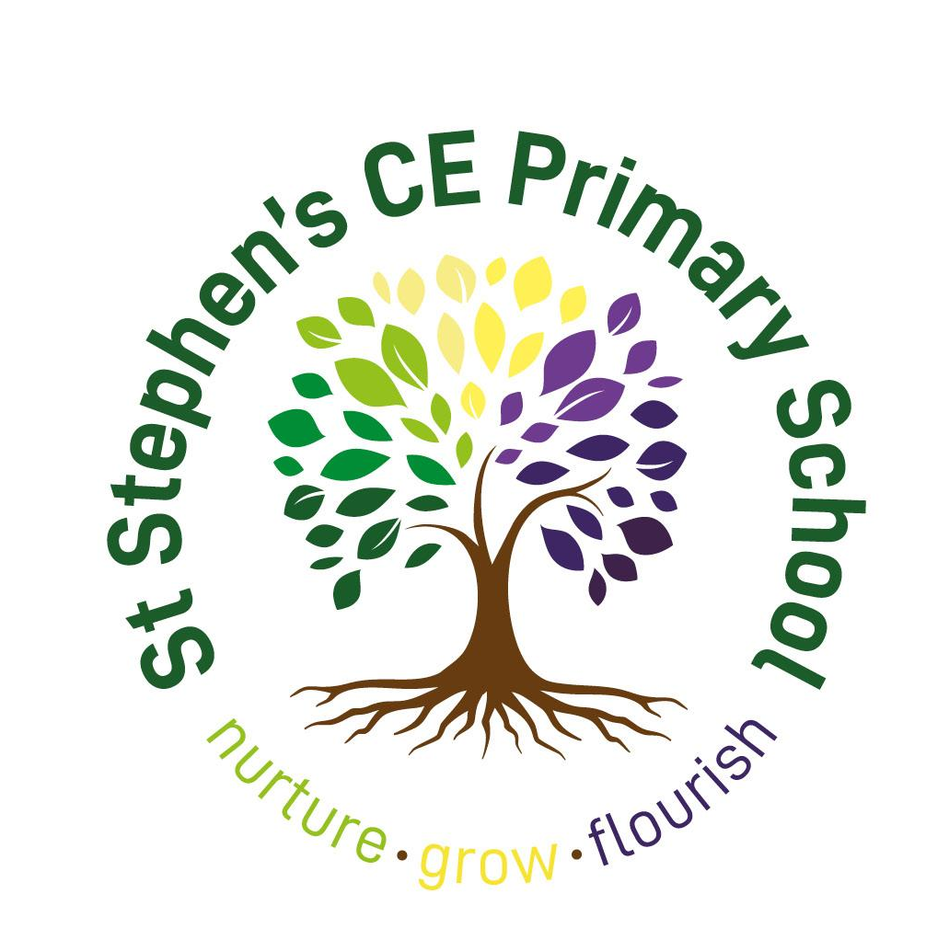

Behaviours Policy

2022-2023

This policy was updated in October 2022 and adopted by the Full Governing Body on_____.

Signed (Head teacher)

Signed (Chair of Governors/Committee)

This policy is due for review in September 2023.

Table of Contents
Introduction 4
Written Principles 4
Legal framework 5
Aims 7
Roles and Responsibilities 8
Governing Body 8
Headteacher 8
Mental health lead 9
SENCO 9
Teaching staff 10
Other members of staff, volunteers and support staff 10
Pupils 10
Parents 11
Definitions 12
Our School Culture 13
Learning Goals – expectations, not rules 13
Gospel Values 14
Our Curriculum 15
Research based practice 17
The Elton Report 17
The three Rs of the behaviour curriculum: 17
The education endowment fund (EEF) 18
Effective Behaviour Management in Schools 19
Nurture – nurturing appropriate behaviour 19
Know and understand your pupils and their influences 19
Role models in school 19
Our community 19
Supporting mental health and wellbeing 20
Adverse childhood experiences 20
Bullying 21
Our learning environments 21
Grow – developing appropriate behaviour 23
Teach learning behaviours alongside managing inappropiate behaviour 23
Behaviours for learning 25
Rewards or recognition? 25
Dojos 25
Flourish – embedding appropriate behaviour 26
Use simple approaches as part of your regular routine 26
Use targeted approaches to meet the needs of individuals in your school 27
Rewards and Sanctions 27
Celebrating and giving recognition to learning 27
Behaviour for learning 27
Consequences 27
The Consequence Scale 28
Restorative Practice 31
Specific behaviours 32
Individual support (SEND) 32
Use of reasonable force 33
Conduct Outside the School Gates 36
Confiscation of inappropriate items 36
Smoking and controlled substances 37
Sexual abuse and discrimination 37
Prohibited sexual harassment 38
Prohibited items, searching pupils and confiscation 39
Data collection and behaviour evaluation 40
Monitoring and review 40
Bibliography 41
Appendix 1 A summary guide for staff 42
Appendix 2 – Recording Behaviour Incidents on CPOMS 47

Introduction

This behaviours policy covers all aspects of pupils’ conduct, interactions, learning and wellbeing. This document has taken into account research, historical best practice and our underlying principles as a Church of England Primary school.

Written Principles

Our Behaviours Policy is centred around all staff having an unconditional positive regard for all our pupils. This means all staff have a basic acceptance of, and respect for, all pupils, regardless of what they say or do, which permeates our interactions with them and discussions about them. This mirrors our belief in God’s unconditional love for all.
Our school motto, ‘Nurture, Grow, Flourish’ is present throughout our approach to behaviour within school.
Our primary concern is the safety, wellbeing and education of all pupils; actions taken in cases of inappropriate behaviour are with the intention of upholding their wellbeing and academic progress, as well as fulfilling our safeguarding responsibilities.
We will create a calm and orderly environment to enable pupils to learn effectively.
We prioritise inclusion and will ensure that all members of our school community are able to enjoy the activities of our school free from any discrimination. We will create and maintain an atmosphere and ethos of acceptance, equality, diversity, respect, understanding and kindness throughout our school community in everyday practice. We aim to foster a collective ethos amongst all members of our school community, and promote values of caring, empathy, teamwork and coordination.
We endeavour to ensure that all pupils, staff and visitors feel safe in our school environment at all times through a high quality of care, support and guidance.
All pupils have a right to fulfil their greatest academic and personal potential and feel they are valued members of our school community, and should be free from bullying, discrimination and distracting peer behaviour.
We ensure that rules are consistently applied across school and where sanctions are exercised, they are in line with our school’s Behaviours Policy and are taken seriously. Good behaviour at school is acknowledged and rewarded at the discretion of all staff, who will judge appropriately.
We offer comprehensive support to pupils displaying problematic behaviour, before and/or alongside disciplinary measures taking into account pupils’ home circumstances and any SEND.
Any kind of violence, threatening behaviour or abuse between pupils, or by members of our school community towards our school’s staff, will not be tolerated. If a parent does not conduct themselves properly, we reserve the right to ban them from the school premises and, if the parent continues to cause disturbance, they may be liable to prosecution.
Guidance on the use of physical intervention will be agreed upon by the headteacher and governing body, and clearly set out within our school’s Behaviours Policy and Physical Intervention Policy.
We uphold clear and effective policies with clearly defined consequences for poor behaviour, that are applied consistently and fairly by all staff.
General expectations
We have high expectation for pupils’ behaviour and conduct. These expectations are commonly understood and applied consistently and fairly. We set clear routines and expectations for the behaviour of pupils across all aspects of school life, not just in the classroom.
We make behavioural expectations and the related policies clear and accessible to members of our school community, and ensures the community agrees they are fair and reasonable. These will be made readily available to read and general expectations will be displayed in classrooms and around school. Our emphasis is on encouraging and praising good behaviour for learning and supporting individuals who are struggling to meet the expected behavioural standards. Each pupil receives the necessary behavioural support according to their specific needs.
We create a positive and respectful culture in which staff know and care about pupils.
We do not tolerate offensive or insulting language in any circumstances and expects polite and considerate behaviour to be maintained by all. Bullying, discrimination, sexual harassment, sexual abuse and sexual violence are not tolerated, online or offline. Pupils are encouraged to report any case of bullying they experience or observe to school staff, and wherever such behaviour occurs it will be dealt with quickly, consistently and effectively.
We support pupils to play a highly positive role in creating an environment in which commonalities are identified and celebrated, difference is valued and nurtured, and bullying, harassment and violence are never tolerated. All pupils are taught to actively support the wellbeing of other pupils.
All pupils are expected to behave consistently well, demonstrating high levels of self-control and consistently positive attitudes to their learning.
Pupils are held to high standards of attendance. We will take swift, appropriate and action to ensure that problems of lateness and absence are handled effectively.
Staff lead by example and model their conduct in line with our school’s standards. This statement, and the policies that are influenced by it, applies to all pupils and staff inside and outside of school.

Legal framework

This policy has due regard to all relevant legislation and statutory guidance including, but not limited to, the following:

- Education Act 1996
- Education Act 2002
- Equality Act 2010
- Educations and Inspections Act 2006
- Health Act 2006
- The School Information (England) Regulations 2008
- DfE (2016) ‘Behaviour and discipline in schools’
- DfE (2018) ‘Sexual violence and sexual harassment between children in schools and
colleges’
- DfE (2018) ‘Mental health and behaviour in schools’
- DfE (2015) ‘Special educational needs and disability code of practice: 0 to 25 years’
- DfE (2013) ‘Use of reasonable force’
- Voyeurism (Offences) Act 2019
- DfE (2021) ‘Keeping children safe in education 2021’
- DfE (2021) ‘Sexual violence and sexual harassment between children in schools and colleges’

This policy operates in conjunction with the following school policies:

- Anti-Bullying Policy
- Social, Emotional and Mental Health (SEMH) Policy
- Special Educational Needs and Disabilities (SEND) Policy
- Child Protection and Safeguarding Policy
- Exclusion Policy
- Physical Restraint and Reasonable Force Policy
- Complaints Procedures Policy
- Child-on-child Abuse Policy

Aims

This policy aims to:

- Provide a consistent approach to behaviour management
- Define what we consider to be unacceptable behaviour, including bullying
- Summarise the roles and responsibilities of different people in the school community with regards to behaviour management
- Outline our systems for recognising expected behaviour and the consequences inappropriate behaviour

Roles and Responsibilities

Governing Body

Responsible for:
- Making a statement of behaviour principles, and providing guidance for the headteacher on promoting good behaviour where appropriate.
- The monitoring and implementation of this Behaviours Policy and of the behaviour procedures at the school. This includes the policy’s effectiveness in addressing any SEMH-related drivers of inappropriate behaviour.
- Ensuring that this policy, as written, does not discriminate on any grounds, including, but not limited to, age, disability, gender reassignment, marriage and civil partnership, race, religion or belief, sex and sexual orientation.
- Promoting a whole-school culture where calm, dignity and structure encompass every space and activity.
- Handling complaints regarding this policy, as outlined in the school’s Complaints Procedures Policy.
- Ensuring this policy is published on the school website.

Headteacher

Responsible for:
- The monitoring and implementation of this policy and of the behaviour procedures at the school. This includes the policy’s effectiveness in addressing any SEMH-related drivers of inappropriate behaviour.
- Acting in accordance with the statement of behaviour principles made by the governing board, and having any regard to guidance provided by the governing board on promoting good behaviour.Establishing high expectations of pupils’ conduct and behaviour, and implementing measures to achieve this.
- .
- Reporting to the governing body on the implementation of this Behaviours Policy, including its effectiveness in addressing any SEMH-related issues that could be driving disruptive behaviour.
- Publishing this policy and making it available to staff, parents and pupils at least once a year.
- Determining the school’s expectations for behaviour, and consequences for inappropriate behaviour.
- The day-to-day implementation of this policy.

Mental health lead

Responsible for:
- Overseeing the whole-school approach to mental health, including how this is reflected in the school’s Behavioural Policy, how staff are supported with managing pupils with SEMH-related behavioural difficulties, and how the school engages pupils and parents with regards to the behaviour of pupils with SEMH difficulties.
- Collaborating with the SENCO, headteacher and governing body, as part of the Leadership Team, to outline and strategically develop behavioural and SEMH policies and provisions for the school.
- Coordinating with the SENCO and mental health support teams to provide a high standard of care to pupils who have SEMH-related difficulties that affect their behaviour.
- Advising on the deployment of the school’s budget and other resources, such as SEND resources and the pupil premium, to effectively meet the needs of pupils with SEMH-related behavioural difficulties.
- Providing professional guidance to colleagues about SEMH difficulties and the links with behaviour, and working closely with staff, parents and other agencies, including SEMH charities.
- Referring pupils with SEMH-related behavioural difficulties to external services, e.g. specialist children and young people’s mental health services (CYPMHS), to receive additional support where required.
- Overseeing the outcomes of interventions on pupils’ behaviour, education and overall wellbeing.
- Liaising with parents of pupils with SEMH-related behavioural difficulties, where appropriate.
- Liaising with other schools, educational psychologists, health and social care professionals, and independent or voluntary bodies.
- Liaising with potential future providers of education, such as secondary school teachers, to ensure that pupils and their parents are informed about options and a smooth transition is planned.
- Leading CPD on mental health and behaviour.

SENCO

Responsible for:
- Collaborating with the governing body, headteacher and the mental health lead, as part of the Leadership Team, to determine the strategic development of behavioural and SEMH policies and provisions in the school.
- Undertaking day-to-day responsibilities for the successful operation of the behavioural and SEMH policies to support pupils with SEND.
- Supporting subject teachers in the further assessment of a pupil’s strengths and areas for improvement and advising on the effective implementation of support.

Teaching staff

Responsible for:
- Being aware of the signs of SEMH-related behavioural difficulties.
- Planning and reviewing support for their pupils with SEMH-related behavioural difficulties in collaboration with parents, the SENCO and, where appropriate, the pupils themselves.
- Setting high expectations for every pupil and aiming to teach them the full curriculum, whatever the prior attainmentPlanning lessons to address potential areas of difficulty to ensure that there are no barriers to every pupil achieving their full potential, and that every pupil with SEMH-related behavioural difficulties will be able to study the full national curriculum.Teaching and modelling expected behaviour and positive relationships, demonstrating good habits.
- Being responsible and accountable for the progress and development of the pupils in their class.
- Being aware of the needs, outcomes sought, and support provided to any pupils with SEMH-related behavioural difficulties.
- Keeping the relevant figures of authority up-to-date with any changes in behaviour. The relevant figures of authority include: Headteacher, SENCO, DSL, and Leadership Team
- Not tolerating disruption and taking proportionate action to restore acceptable standards of behaviour.

Other members of staff, volunteers and support staff

- Adhering to this policy and applying it consistently and fairly.
- Supporting pupils in adhering to this policy.
- Promoting a supportive and high-quality learning environment.
- Modelling high levels of behaviour.
- Being aware of the signs of behavioural difficulties.
- Setting high expectations for every pupil.
- Being aware of the needs, outcomes sought, and support provided to any pupils with specific behavioural needs.
- Keeping the relevant figures of authority up-to-date with any changes in behaviour. The relevant figures of authority include:
- SENCO.
- Headteacher.
- Subject leader.
- As authorised by the headteacher, sanctioning pupils who display poor levels of behaviour.

Pupils

Responsible for:
- Their own behaviour both inside school and out in the wider community.
- Following expectations for behaviour at all times.
- Reporting any unacceptable behaviour to a member of staff.

Parents

Responsible for:
- Supporting their child in adhering to the school’s expectations for behaviour..
- Informing the school of any changes in circumstances which may affect their child’s behaviour.

Definitions

For the purposes of this policy, the school defines “low-level inappropriate behaviour” as any behaviour which may disrupt the education of the perpetrator and/or other pupils, including, but not limited to, the following:

- Lateness
- Low-level disruption and talking in class
- Failure to complete classwork
- Rudeness
- Use of mobile phones without permission
- Graffiti

“Low-level inappropriate behaviour” may be escalated to “serious inappropriate behaviour”, depending on the severity of the behaviour.
For the purposes of this policy, the school defines “serious unacceptable behaviour” as any behaviour which may cause harm to oneself or others, damage the reputation of the school within the wider community, and/or any illegal behaviour. This includes, but is not limited to, the following:

- Discrimination – not giving equal respect to an individual on the basis of age, disability, gender identity, marriage and civil partnership, pregnancy and maternity, race, religion or belief, sex, and sexual orientation
- Harassment – behaviour towards others which is unwanted, offensive and affects the dignity of the individual or group of individuals
- Vexatious behaviour – deliberately acting in a manner so as to cause annoyance or irritation
- Bullying – a type of harassment which involves personal abuse or persistent actions which humiliate, intimidate, frighten or demean the individual being bullied
- Cyberbullying – the use of electronic communication to bully a person, typically by sending messages of an intimidating or threatening nature
- Possession of legal or illegal drugs, alcohol or tobacco
- Possession of banned items
- Truancy and running away from school
- Refusing to comply with disciplinary sanctions
- Theft
- Verbal abuse, including swearing, racist remarks and threatening language
- Fighting and aggression
- Persistent disobedience or destructive behaviour
- Extreme behaviour, such as violence and serious vandalism
- Any behaviour that threatens safety or presents a serious danger
- Any behaviour that seriously inhibits the learning of pupils
- Any behaviour that requires the immediate attention of a staff member

Our School Culture

At St Stephen’s, we understand that the way students behave in school is strongly correlated with the eventual outcomes. We aim to nurture every child, to ensure that they grow and can flourish as contributing adults to society. We achieve this by:

- Helping each child to feel happy, safe and secure in the school.
- Encouraging children/staff, whilst learning and developing in a Christian environment, to celebrate their uniqueness and develop respect for each other.
- Helping children to develop a social responsibility within the community, as they increase their understanding of the world we live in, so that in future, they will be active, responsible citizens.
- Helping children recognise their achievements, uniqueness and to have high aspirations for the future.
- Enabling each child to develop skills for life so they become increasingly independent personally, socially and in their learning.

Learning Goals – expectations, not rules

Positive behaviour is linked to good behaviour for learning. By focusing and rewarding these behaviours for learning, behaviour for conduct will follow. This is not the case in reverse.

We therefore, acknowledge, publicise and celebrate eight Learning Goals. These are central to our Curriculum

Rather than using the language of ‘rules’, we use our Learning Goals as a set of ‘Expectations’ for everybody’s behaviour, including pupils and staff.

Learning Goals underpin the individual qualities and dispositions we believe children will find essential in the 21st century. The eight Learning Goals are being: a thinker, resilient, ethical, a collaborator, a communicator, empathetic, respectful and adaptable.

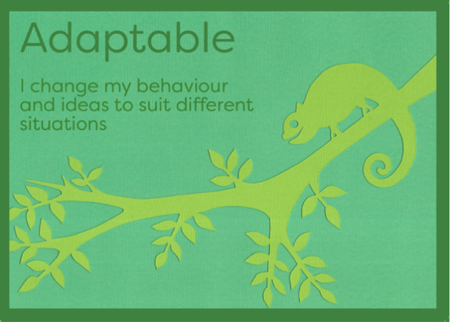 | 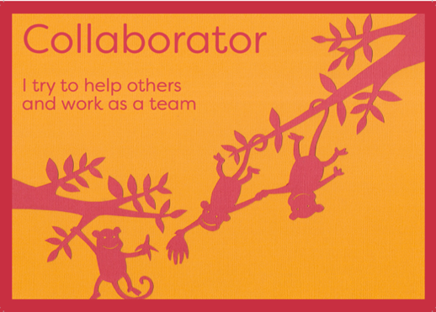
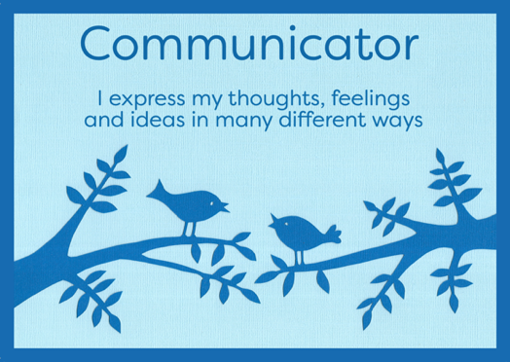 | 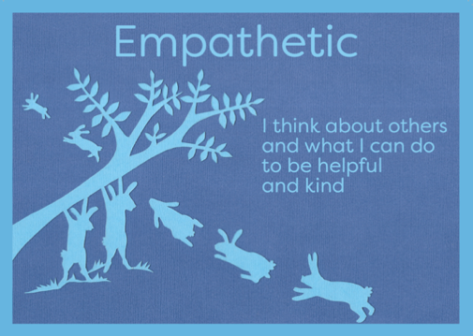
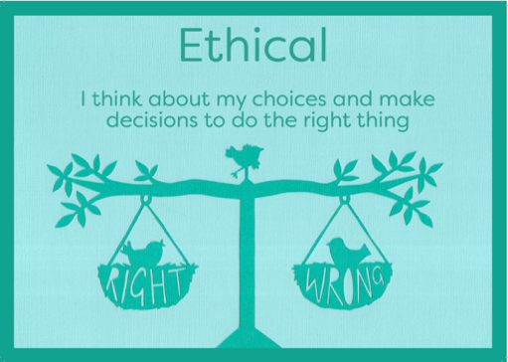 | 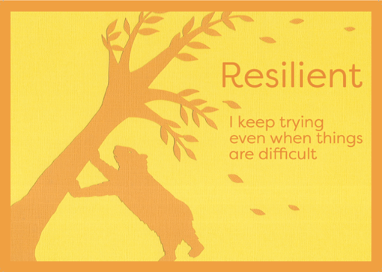
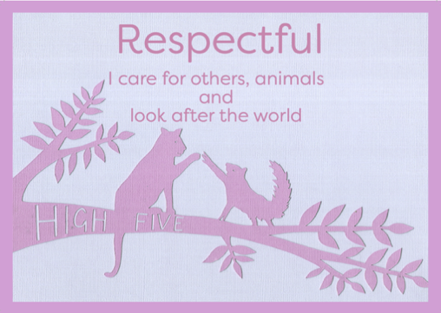 | 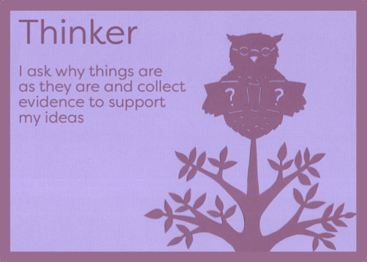

Gospel Values

Our Gospel Values form the focus of our spiritual development, and are central to our yearly cycle of Collective Worship. Although some overlap with our Learning Goals, they are chosen due to how they relate to, but are not exclusive to, the Christian faith, and our life as a church school. They are promoted explicitly in at least three of our five weekly acts of Collective Worship.

Generosity: Here at St Stephen’s pupils are encouraged to show generosity through kindness and giving, whether this is through time, support or charity.

Compassion: Here at St Stephen’s pupils are encouraged to show understanding of others less fortunate than themselves and show kindness and empathy.

Courage: Here at St Stephen’s pupils are encouraged to show courage and bravery through trying new experiences and pushing themselves to achieve their potential.

Forgiveness: Here at St Stephen’s pupils are encouraged to forgive others and reflect on others’ actions with mercy and grace. Forgiveness is one of the many values encouraged through the schools’ behaviour policy.

Friendship: Here at St Stephen’s pupils are encouraged to be the best friend they can be by showing kindness and thoughtfulness of others.

Respect: Here at St Stephen’s children are encouraged to go on a path of self-discovery. Children learn how to take responsibility for their own learning and personal development, as well as how to treat and respect others.

Thankfulness: Here at St Stephen’s pupils are encouraged to self-reflect for what they are thankful for and to write their own prayers of thanks for whole school worship.

Trust: Here at St Stephen’s pupils are encouraged to trust one another and have a firm belief in the school and its systems, resulting in pupils who are positive and confident in their learning.

Perseverance: Here at St Stephen’s we work together to overcome any obstacles, however challenging, to achieve our goals. We try and try again, building resilience which helps us deal with any disappointments on our journey to success.

Justice: Here at St Stephen’s pupils are encouraged to promote British and Co-operative Values and attitudes of democracy, rule of law, individual liberty, tolerance of others and justice within the school and wider communities.

Service: Here at St Stephen’s pupils are encouraged to understand the idea of service and how they can support the school community, the local community and the international community through charity.

Truthfulness: Here at St Stephen’s pupils are encouraged to pursue truthfulness and promote honesty at all times.

Our Curriculum

Lessons are structured to be interesting and appropriately challenging. Children are made active partners in their learning with some choice over curriculum content and have opportunities to make choices. Children learn in different ways and teachers’ planning addresses children’s different learning styles. All children are made aware of what is expected of them at the beginning of each lesson.

Appropriate behaviours are taught and reinforced on a regular basis. Children are taught how to use thinking skills and feelings together to guide their behaviour using taught calming down strategies, problem solving and conflict management techniques. Appropriate behaviour is quickly noticed and celebrated.

Praise is warm, labelled, sounds like it is meant and given with smiles and good eye contact.

Teaching routinely incorporates activities designed to promote children’s social skills and emotional development. The delivery of the PSHE curriculum offers a structured, spiral curriculum for developing the social, emotional and behavioural skills of all children, supported by a SEMH support system called Woodlands.

Research based practice

The Elton Report

The Elton report (DES 1989) was a major study on behaviour and discipline in schools. It suggested a major shift with regards to the management of behaviour in schools by encouraging a move towards whole school approaches to behaviour and discipline. The underlying premise was that pupils’ behaviour could be influenced by all the major features and processes of school, including the quality of its leadership, classroom management, behaviour policy, curriculum, pastoral care, buildings and the physical environment, organisation and timetable and relationships with parents.
The Elton reports advised that teachers should:

- Know their pupils as individuals. This means knowing the names, their personalities and interests and who their friends are.
- Plan the lesson to keep pupils interested and minimise the opportunities of disruption.
- This requires attention to such basics as furniture layouts, seating of pupils, matching work to pupils’ abilities, pacing lessons well, being enthusiastic and using humour to create a positive classroom atmosphere.
- Be flexible in order to take advantage of unexpected events rather than being thrown off balance by them.
- Continually observe or scan the behaviour of the class.
- Be aware of, and control their own behaviour, including stance and tone of voice.
- Model the standards of courtesy they expect from pupils.
- Emphasise the positive, including praise for good behaviour as well as good work.
- Make sparing and consistent use of reprimands. This means being firm rather than aggressive, targeting the right pupils, criticising their behaviour and not the person, using private rather than public reprimands whenever possible, being fair and consistent and avoiding sarcasm and idle threats.
- Make sparing and consistent use of punishments. This includes avoiding whole group punishments, which pupils see as unfair. It also means avoiding punishments that humiliate pupils by, for example, making them look ridiculous. This breeds resentment.
- Analyse their own classroom management performance and learn from it.

The three Rs of the behaviour curriculum:

- Routines. Classroom and around school routines are a fundamental source of high expectation. Routines provide this scaffold for conduct and a community vision of optimal habits and behaviour.
- Responses. Strategies and interventions for deescalating confrontation, resolving conflicts, redirecting unproductive or destructive behaviour, and reacting to antisocial behaviour in a just, productive and proportional way. These include formal interventions: for example, consequences outlined later and informal ones, for example, verbal and non-verbal cues, body language.
- Relationships. Regulating one’s own emotional state; understanding personal triggers in one’s own behaviour, expectations or reactions; how special educational needs and disability affect behaviour. Understanding for example ADHD, autism, dyslexia Asperger’s; the basic psychology of motivation and long- and short-term memory, concentration learning, cognitive load spacing and interleaving and dynamics.

The education endowment fund (EEF)

The education endowment fund (EEF) has undertaken extensive research on behaviour in schools. There are three areas in which they recommend schools focus on with regards to their behaviour(s) policy.

Firstly, is the importance of knowing individual pupils well, so that schools and teachers know which factors might affect pupil behaviour and what the school can do to address these.
Focusing on developing good relationships also ensures pupils feel valued and supported, meaning they are less likely to misbehave. It is also good that many simple approaches that don’t take much time or money to implement—like providing breakfast clubs, or greeting pupils individually before a lesson—can have a really positive impact on behaviour.

The second focuses on how to deal with bad behaviour when it happens. A key message is that schools should use personalised approaches—like daily report cards—to address ‘problem pupils’, rather than universal systems. It recommends that teachers are trained in specific strategies if they’re dealing with pupils with high behaviour needs.

The third focuses on the importance of consistency and coherence when it comes to
behaviour policies. This means that once senior leaders have considered the rationale for putting a new behaviour strategy or approach to work, they need to spend time and care embedding it across the entire school.

Effective Behaviour Management in Schools

Research shows that there are some key features of effective whole school management.

- A clear and detailed sense of purpose and strategy.
- A robust, firm communication of purpose and strategy from all members of the school community.
- Consistency between all staff and students about cultural and academic norms.
- Close attention to detail. Every aspect of school life from playtimes to walking around school are considered thoughtfully. The policy itself spells out in sufficient detail and clarity and is constantly referred to and made explicit throughout a pupil’s course of school life.
- Well-advertised, repeatedly demonstrated routines in every aspect of civil and academic conduct. There are consistent and clear expectations of habitual conduct. Any aspect of school life that could successfully be made into routine should be clearly defined as such.
- Commitments to every student’s well-being and success, despite the challenges they may present. Every pupil is seen as an opportunity for success rather than a vehicle for failure. When students fail to behave it is seen as a problem to be solved rather than merely a nuisance.

Nurture – nurturing appropriate behaviour

Know and understand your pupils and their influences

Pupil behaviour has multiple influences, some of which teachers can manage directly. Understanding a pupil’s context will inform effective responses to misbehaviour. Every pupil should have a supportive relationship with a member of school staff.

Role models in school

Pupils need to see others behaving well in order to emulate them. This is consistent with the view that social norms are powerful inhibitors and catalysts of behaviour. What is seen commonly is absorbed as custom. In these regards, it is important for staff and pupils to see exemplary behaviour. It is essential that staff are key role models as well as pupils

Our community

At St Stephen’s we are aware that we are members of our community, serving our community and composed of our community. Our success rests upon making strong links between ourselves, parents, local businesses, community groups and institutions. This helps pupils to see themselves as members of both the school community and our community at large, which contributes to their identity as social beings.

Supporting mental health and wellbeing

Below is our list of in-school influences that the Department for Education has identified as affecting pupil mental health. These could play a major role in behaviour presented in the classroom. Consideration of the influences and the extent to which the school can influence them should lead to a more effective choice of strategies when considering how to create policies and individual response plans for positive and negative behaviours in school.

Risk factors | Protective factors
- Bullying including online  - Discrimination  - Breakdown in all lack of positive friendships  - Deviant peer influences  - Peer pressure  - Peer on peer abuse  - Poor pupil to teacher/School staff relationships | - Clear policies on behaviour and bullying  - Staff Handbook (Aka code of conduct)  - Open door policy for children to raise problems  - A whole school approach to promote good mental-health  - Good pupil to teacher/school staff relationships  - Positive classroom management  - A sense of belonging  - Positive peer influences  - Positive friendships  - Effective safeguarding and child protection policies  - Understand their role in and be part of effective multiagency working  - An effective early help process  - Appropriate procedures to ensure staff are confident to raise concerns about policies and processes, and know that they will be dealt with fairly and effectively.

Adverse childhood experiences

There is a growing body of research identifying the harmful effects of adverse childhood experiences (ACEs) on the rest of a person’s life. ACEs are significant stressful events occurring during childhood or adolescence and can be direct, such as the child suffering abuse or neglect, or indirect, such as the child’s parent suffering mental illness or drug addiction. The research suggests that ACEs have a strong link with chronic diseases, social and emotional issues, with a higher ACE score correlating with worse outcomes on all fronts. Two thirds of people have at least one ACE, but the 8% of people in England who have four or more ACEs are at an increased risk of a range of negative health outcomes.

Bullying

A key influence on a child’s behaviour in school is being the victim of bullying. In causing stress for the pupil, being bullied is linked to lower attainment outcomes. School approaches to prevent and respond to bullying must involve establishing and maintaining high quality behaviour management throughout the whole school with support from parents and other stakeholders.

In the systematic review and meta-analysis of anti-bullying programs produced by the Campbell Corporation in 2009, the authors reviewed 53 school initiatives and found that successful programs tended to be more intensive and implemented over an extended period, and contain the following elements

- Whole school anti-bullying policy.
- School conferences: collective worship to introduce the initiative and inform pupils about bullying.
- Co-operative group work: School staff cooperating to work with bullies and victims of bullying.
- Information for parents: this could include a manual to structure teachers’ conversation or a leaflet for parents to digest at home.
- Improved playground supervision
- Classroom management.

Our learning environments

This is important because our successes in promoting co-operation and in de-escalating conflict have a huge impact on the amount and the quality of learning taking place in our classrooms.

The St Stephen’s environment promotes an atmosphere where children and young people benefit from positive relationships with other students and staff. Students respond more positively when staff actively foster positive relationships based upon trust and mutual respect.

Planning in this way helps staff to remain calm, assertive and decisive. An assertive teacher or professional’s verbal and body language convey expectation, e.g. that he/she expects good behaviour.

Staff must ensure the following are addressed in lesson and non-lesson time in order to avoid unnecessary triggers or opportunities for disruptive behaviour thereby establishing an effective and purposeful climate for learning:

- Establish and maintain a consistent routine for lining up groups on entry to the learning space; meeting and greeting before the learning commences. Interaction must be positive, engaging and purposeful in order to ‘set the tone’ for the learning.
- Establish and maintain a consistent routine for an orderly end to the learning and exit from the learning space e.g. students pack away when instructed to do so (not by pupil choice).
- Keep live, pre-planned seating plans where each pupil is allocated a seating position in the class based on a number of factors e.g. ability, learning need, positive working partnership, specific contribution to group work or need for isolation as part of planned intervention. Enabling pupils’ free choice of seating does not always promote the most effective learning and can negatively influence the climate for learning.
- Model high expectations of behaviour and the academic capabilities of the pupils– the adult must model, recognise and fairly reward the ‘can do’ attitude of every pupil which must underpin every learning experience.
- Be prepared through well planned, appropriately resourced and engaging learning experiences. All teachers must apply the teaching and learning policy. Equipment and resources must be ready at all times.
- Adults must have due regard for those who require specific learning resources, personalised learning strategies or specific adjustments needed for the context. It is an expectation that the teacher plans carefully with the ‘Other Adult’ to ensure the student engages fully in the mainstream learning environment.
- Apply appropriate, transparent and regular use of the recognition and consequences system.
- Use appropriate praise and positive reinforcement through positive learning behaviours. This helps to build self-esteem, mutual respect and trust.

Where staff intervention is required, this is best done by avoiding immediate use of the Behaviour Consequences System. The Behaviour Consequences System can quickly escalate the problem because if the teacher rapidly ‘raises the stakes’, many pupils will respond accordingly. It is far better to employ a range of verbal and non-verbal cues such as:

- Tactical ignoring to be picked up later;
- Non-verbal signals (e.g. ‘the look’);
- Move closer;
- Say names;
- Use humour;
- Tell them what you want them to do (i.e. clear and simple statement of behaviour);
- Catch student behaving appropriately and praise;
- Praise appropriate behaviour of nearby student;
- Distract onto task/away from inappropriate behaviour;
- Re-explain and organise task for the student;
- Ask the student to undertake a specific task for you;
- Modify or change activity;
- Informally move or change group setting; Additional strategies to be used as required:
- Name – pause – direction;
- Give start up time (expectation of compliance);
- Keep the focus on the primary or original behaviour/issue (i.e. don’t be deflected onto secondary behaviour/issue);
- Broken record technique (Different words but repeating same message);
- Use the language of choice, remind of consequences (‘If you choose to….then…);
- Use ‘I messages’ (‘I – your feeling – their behaviour – what they need to do instead’).

To do this, staff use assertive communication skills such as:

- Non-verbal cues;
- Eye contact;
- Closing the space;
- Using gesture;
- Maintaining a quiet/ calm tone of voice;
- Verbal scripts;
- Learning and using names;
- Circulating the room;
- No hands up questioning; And assertive language such as:
- ‘I need you to . . .’
- ‘I understand that you want to . . .’
- ‘Concentrate on your work, thank you’
- ‘You are coming into the room quietly and getting your starter activity without
me having to help you. Well done.’
- ‘Well done to Bilal, Mark and Simra for getting on with work quietly.’
- ‘If you choose to continue in that way you will be choosing to be sent to P2.’

Grow – developing appropriate behaviour

Teach learning behaviours alongside managing inappropiate behaviour

The factors that affect pupil behaviour are primarily affected by school. Learning behaviours therefore fall within the realm of the school’s – and even the individual teacher’s – and are therefore central to behaviour management. A model showing this influence is from Powell and Tod (2004)
Relationship
with self
Community / Cultures

Relationship with self
Services
Learning
behaviour
Family
Relationship
with others
Relationship
with curriculum

In this model, a single learning behaviour (from those detailed below) is placed at the centre of the model. The triangle surrounding this behaviour is the ‘triangle of influence’, representing the behaviour being influenced by emotional, social, and cognitive factors. These factors and the learning behaviour itself can be addressed through the three relationships (with self, others, and the curriculum) experienced by the individual in the classroom.

Changing a learning behaviour is a dynamic process with reciprocal influences, as represented by the arrows. The circle, and terms inside this, show the influence of context.

A range of learning behaviours is outlined below:

- Emotional learning behaviours
- inner voice, mental well-being, dealing with setbacks; and self-esteem, self-worth, and self-competence.
- Social learning behaviours:
- pupil relationship with teacher, pupil relationship with peers, collaborative learning, and bullying.
- Cognitive learning behaviours:
- motivation, growth mind-set, working memory/ cognitive load, and communication—improving through effective teacher-pupil dialogue, modelling.

Behaviours for learning

A learning behaviour can be thought of as a behaviour that is necessary in order for a
person to learn effectively in the group setting of the classroom.

The three behaviour for learning relationships are:

- Relationships with the curriculum (Predominantly cognitive);
- Relationship with others (Predominantly social);
- Relationships with self (Predominantly emotional).

A teacher hoping to improve this pupil’s responses to setbacks could respond by:

- increasing engagement (relationship with self)— discussing a time the pupil has given up when experiencing a setback and challenging them to stick with the next task, listening to any concerns the pupil has about being able to achieve or issues with self-motivation;
- improving access (relationship with curriculum)—ensuring the pupil has appropriately- levelled work that will lead to the experience of success as long as they stick with it; praising the pupil for achieving and highlighting that their perseverance got them through it.
- ensuring participation (relationship with others)— set a classroom culture where pupils are proud to say they found a task difficult at first and are not afraid to get things wrong.

Rewards or recognition?

‘Rewarding’ appropriate behaviour can result in pupils behaving in a certain way in order to receive a reward, rather than doing the right thing because it’s the right thing to do.
However, we want to recognise the behaviours for learning pupils show in school, and believe that appropriate behaviour for conduct will follow.

Dojos

Putting in place clear recognition systems can improve pupil behaviour in the classroom when used as part of a broader teacher classroom management strategy. At St Stephen’s, we have adopted ‘Dojos’ because this is directly linked to our learning goals.

‘Rewarding’ appropriate behaviour can result in pupils behaving in a certain way in order to receive a reward, rather than doing the right thing because it’s the right thing to do.
However, we want to recognise the behaviours for learning pupils show in school, and believe that appropriate behaviour for conduct will follow.

At St Stephen’s, pupils earn dojos for demonstrating these goals.

Teachers should recognise pupils’ behaviour for learning by awarding ‘Dojos’ to individuals or the whole class.
- Dojos should be given in units of one (no more than one should be given at a time).
- Dojos awarded must always be linked to a specific Learning Goal which should be listed as a ‘skill’ in Class Dojo.
- Each member of staff (including LSAs) should have their own Dojo account, and it should be linked to all classes that they teach in.
- Each child who receives more than 15 dojos in a week will be able to choose a privilege from the ‘Privilege Pantry’. The list of items should be drawn up and chosen with each class, e.g. choosing some music to listen to one afternoon, 10 minutes of teaching the class, eating lunch with a chosen member of staff.
- The number of dojos should be reset each week. This is to allow pupils to start each week with a clean sheet, and prevents pupils from falling behind others.
- Dojos must never be taken away from pupils.
- The Dojo account for each class should be shared with the appropriate Phase Leader, and the Senior Assistant Head, Deputy Head and Head Teacher, as well as other staff who teach them.

Collective Recognition
If the class total of dojos in a week reaches 300, the whole class may choose from the class Privilege Pantry. Pupils should be encouraged to work collaboratively towards this total.
Superstars
Each week two pupils from each class should be chosen to be the class ‘Superstars’. These pupils are given a certificate and may wear a superstar medal for the week. These will be presented in our Celebration Collective Worship.

Flourish – embedding appropriate behaviour

Use simple approaches as part of your regular routine

The message here is not to overlook simple things done well, such as:

- greeting each student positively at the door;
- giving specific behaviour-related praise throughout the lesson;
- using simple approaches to improve teacher– student relationships;
- using checklists to ensure behaviour policies and procedures are embedded with rigour.

Most of these strategies have little or no cost, yet the research suggests that they could reduce challenging behaviour and lead to improved attainment, improved attendance, and a more purposeful learning climate.

Use targeted approaches to meet the needs of individuals in your school

Universal systems are unlikely to meet the needs of all students. For those pupils who need more intensive support with their behaviour, a personalised approach is recommended.
This may involve targeted interventions implemented by teachers reflecting on the classroom management techniques for the whole class may also be particularly beneficial for the individuals with greater needs. For pupils who are disruptive, targeted interventions are often most effective when adapted to the needs of the individuals involved.,

A tailored approach to support an individual’s behaviour should complement the school’s behaviour policy without lowering expectations of any pupils’ behaviour. The research from OFSTED show low expectations communicated from teachers can detrimentally affect pupils' achievements.

Rewards and Sanctions

Celebrating and giving recognition to learning

Recognition
‘Rewarding’ appropriate behaviour can result in pupils behaving in a certain way in order to receive a reward, rather than doing the right thing because it’s the right thing to do.
However, we want to recognise the behaviours for learning pupils show in school, and believe that appropriate behaviour for conduct will follow.

Behaviour for learning

When behaviour for learning is positive, behaviour for conduct will naturally follow. This is not the case vice versa. Therefore, by focussing on behaviour for learning we see positive behaviours throughout school.

Consequences

Consequences should be clearly communicated: what they are, how they are incurred and avoided. Importantly we must be consistent across the whole school community. The absence of this consistency can be a key factor in the failure of this school behaviour policy to sustain or supports good behaviour.

The reliability of these systems is a key factor in their success. This does not mean that no exceptions can be made (Particularly when there is a good reason, such as when a teacher identifies SEND), but the exceptions must be exceptional, with good reason, and coherent with other exceptions.

Sanctions need not be severe, as Bill Rogers states, their,” certainty is more important than their severity”.

Although this school aims to focus on positives at all times, there are unfortunately occasions when a minority of pupils let themselves, the school and others down through their unacceptable or inappropriate behaviour.

The Consequence Scale

Before using our consequences scale, all staff must focus on using more positive approaches to managing behaviour. The Consequences Scale should only be used if a member of staff is unable to make the positive approaches work, and if a pupil persists in not displaying our Learning Goals.
There are responsibilities on staff as well as pupils when using the Consequences Scale and both should reflect on their actions to reduce these incidents.

To avoid public shaming, the names of pupils on this scale must not be publicly displayed, but could be recorded out of sight.

Pupils on ‘C1’ should be brought back to their own seat as soon as practicably possible, in which case their place on the scale should be reset. Pupils should only continue to move up the scale if their behaviour continues to escalate, but staff should aim to prevent this escalation.

Once a pupil has had a Restorative Conversation, they may return to class, and their place on the consequence scale should be ‘reset’ back to the start.

Below is a summary of the consequence scale, including what action the adult is expected to take.

Level | Consequence | Adult Action
Warning | Verbal warning | - Focus on removing any antecedent, or use other positive or relational technique to support the child to modify their behaviour and prevent escalation to C1.
Consequence – C1  Move within class | Pupil has time out within the classroom | - Monitor child and bring them back to their place as soon as practicably possible, and aim to prevent escalation to C2.
Consequence – C2  Move to another class, and Restorative Conversation | Escorted to another class for up to 10 minutes. | - An adult escorts pupil to another classroom, with work to do.  - Teacher or LSA to hold Restorative Conversation with child/ren involved at earliest opportunity.  - Teacher to record incident on CPOMS
Consequence – C3  (Severe Behaviour)  Brought to see SLT, and Restorative Conversation | Brought to member of Leadership Team | - Leadership Team to hold Restorative Conversation with child and staff involved at earliest opportunity.  - Teacher to record incident on CPOMS
Consequence – C4  Formal Meeting with Parents and Restorative Conversation | Meeting with parent, teacher and Leadership Team | - Class teacher and Leadership Team to meet with parents, hold a Restorative Conversation, and record on CPOMS.
Consequence – C5  Exclusion | Exclusion | - Restorative Conversation with Leadership Team and all parties involved.  - Teacher to record on ABC chart.  - SLT to record on CPOMS.

Every time a child reaches C2, a restorative conversation must take place, and later recorded on CPOMS, using the template below. (Always click the ‘Behaviour’ category) This replaces the need to use a paper ABC Chart.
AREA OF CONCERN – BEHAVIOUR – C [1, 2, 3, 4, 5]
Time of incident:
Subject (if appropriate):
ANTECEDENT
BEHAVIOUR
CONSEQUENCE
OUTCOME OF RESTORATIVE CONVERSATION

Additional guidance on Consequences

C1 - Warn – that the student is now on the first consequence

Where possible, this should be delivered quietly on a one to one basis in a calm and controlled manner without hint of anger or animosity, but perhaps with disappointment in having to do so. Remember the likely response from a student, if you choose to ‘raise the emotional stakes.

Where possible, allow the student start up time to respond to the issuing of this first warning and try to revert back to verbal and nonverbal cues. If the opportunity arises to praise the student for responding appropriately to the first warning, take this opportunity, but again it may be best delivered quietly on a one to one basis.

Remind the student that if they do not address their behaviour at this point they are choosing to be moved.

Remember to:

- Allow ‘take-up time’ and not requiring immediate compliance so pupils do not lose face in front of their peers.
- Noticing as soon as the child begins to behave appropriately and giving positive feedback. “Sam, you’re listening really well” or non-verbally.
- Speaking in a calm, controlled voice, not raising the volume, and refusing to be drawn into argument.
- Negotiating an outcome you can live with, such as “Well I’d like to see at least three sentences written by…….”
- Having a quiet word with the child, rather than a public harangue.
- Referring to the behaviour you require rather than what you don’t want.
- Using gentle humour, but not sarcasm.

C2 - Move the student away from the source or as a way to distract or insist on time out for a few minutes. (C2)

If the student improves at this step, this must be recognised and acknowledged.
Remind the student that it is not too late to rectify their behaviour. If they do not address their behaviour at this point, they are choosing to be removed to C2 and will receive further consequences.

The child is sent to a quiet area of the room to calm down and think about what they should do. This should always be used with firm calmness by the teacher. Time out must always involve adult supervision, under no circumstances should a child be standing in a corridor.

C3 - Remove – member of SLT alerted by a trusted child.

The child will remain with a member of SLT until the next available opportunity for a restorative conversation between teacher and child (the next play time, lunch time or at the end of the day)

- the class teacher must inform parents about any removal on the day
- C3 incidents should be recorded on CPOMS

Severe Behaviours
Occasionally, pupils may display ‘severe’ behaviour, which should be treated as an immediate ‘C3’. The pupil should be immediately escorted to a member of the Leadership Team who will hold a Restorative Conversation between the various parties affected, at the earliest opportunity.
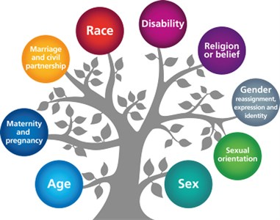
Severe behaviours may include:
- Swearing at another person;
- Fighting;
- Physical aggression towards another person;
- Offensive remarks against a ‘protected characteristic’;
- Bullying;
- Spitting at another person.

We want pupils to take responsibility for their behaviour and will encourage pupils to do this through Restorative Practice approaches which enable pupils to reflect on their behaviour and to make amends (see below) .This process does not, however, replace consequences. At our school, we know that consistency is essential for pupils to understand what is expected of them and to avoid mixed messages. It is vital that children learn early on in life that there are always consequences for poor and unacceptable behaviour which undermine the positive atmosphere of our school community.

In order for pupils to have respect for all adults in school, behaviour will be dealt with by the adult that witnesses the behaviour.

Restorative Practice

What is Restorative Practice?

Restorative Practice is an alternative way of thinking about addressing discipline and behavioural issues and offers a consistent framework for responding to these issues.

We value it at St Stephen’s because it seeks to restore and build relationships between those affected by inappropriate behaviour, and gives all parties an opportunity to reflect on what happened and what each person can do to prevent it from happening again. This is an alternative to pure punishment, which focuses less on repairing damage and relationships.

Restorative approaches enable those who have been harmed to convey the impact of the harm to those responsible, and for those responsible to acknowledge this impact and take steps to put it right.

At each point on the scale from C2 up, an adult and the pupils involved, need to hold a restorative conversation.

At C2, this should be the teacher and pupils. At C3, this should be with the pupils involved, the teacher (or other adult affected) and member of the Leadership Team.

Restorative conversations involve each person being asked a set of questions. To achieve consistency and simplicity, the questions are the same throughout the school.

All staff carry a set of these questions in their lanyards, ready to use, as below.

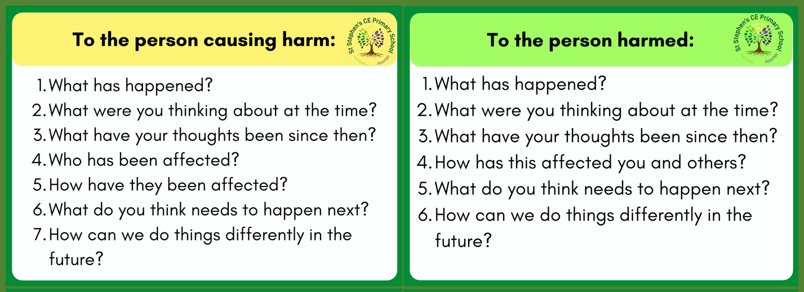

Specific behaviours

Individual support (SEND)

Behaviour will always be considered in relation to a pupil’s SEND.

While pupils with behavioural issues might need a tailored approach, they do not necessarily have a special educational need. Similarly, children with special educational needs and disabilities will not necessarily need additional support with their behaviour. If you know that a pupil who has behavioural issues also has a special educational need, understanding best practice for supporting that particular need may help with their behaviour and thus could be a good starting point for their behaviour support.

There will, always be a small number of children who, for whatever reason, find that they need additional individualised support with their behaviour - early identification and intervention being essential.

To help identify what support may be needed, the class teacher should to clarify the problem by asking the “w” questions:

- What?
- Where?
- With whom?
- When?

Class teacher should:

- Complete the “ABC” chart (Antecedents, Behaviour and Consequences) on CPOMS for a minimum of two weeks and complete the “Factors that may be Influencing behaviour form.”
- An alternative to recording ABC is use of a STAR Chart for situations where pupils continue to display inappropriate behaviour. This may help identify more clearly the triggers of inappropriate behaviour, and may be used on the recommendation of the SENCO or other school leader.
- Discuss the above findings with the SENCO and/or Leadership Team.
- Keep parents informed with respect to behaviour incidents.

SENCO to organise a parent/carer meeting which involves the class teacher to:

- Identify what skills, strengths or positive elements already exist to enable a
- preferred future.
- Ascertain the preferred futures of others and try to merge them.
- Initiate target setting and identify support.
- Consider whether or not an individual plan is necessary.

The SENCO will also consider whether the continuing challenging behaviour might be the result of unmet educational or other needs. At this point, the SENCO will consider whether a Common Assessment Form needs to be completed.

In the case of continued inappropriate behaviour

As a fully inclusive school, we recognise that for some children additional or different action may be necessary as a result of a special educational need or disability. This is in accordance with the SEN Code of Practice. We recognise that a child with social, emotional or behavioural difficulties may require something additional or different in the same way we would differentiate the curriculum for a child with learning needs.

Where this is the case, the child will be identified on our school SEN list. Individual education plans may be needed which outline agreed targets and strategies as well as the ways in which we will support the child. This may include a referral to the SENCO or Learning Mentor. If none of the above are effective, multi-agency involvement will be considered for the child.

Use of reasonable force

In line with the school’s Positive Handling Policy, trained members of staff have the legal right to use reasonable force to prevent pupils from committing an offence, injuring themselves or others, or damaging school property, and to maintain good order and discipline in the classroom.

Physical restraint will only be used as a last resort and as a method of restraint. Staff members will use their professional judgement of the incident to decide whether physical intervention is necessary. The situations in which physical restraint may be appropriate are detailed in the Positive Handling Policy.

Wherever possible, staff will ensure that a second member of staff is present to witness the physical intervention used. After an instance of physical intervention, the pupil will be immediately taken to the headteacher and the pupil’s parent will be contacted – parents may be asked to collect the pupil and take them home for the rest of the day.

Any violent or threatening behaviour will not be tolerated by the school and may result in a fixed-term exclusion in the first instance. It is at the discretion of the headteacher as to what behaviour constitutes for an exclusion.

When using reasonable force in response to risks presented by incidents involving pupils with SEND or medical conditions, the school will recognise and consider the vulnerability of these groups.

What is reasonable force?

The term ‘reasonable force’ covers the broad range of actions used by most teachers at some point in their career that involve a degree of physical contact with pupils.

Force is usually used either to control or restrain. This can range from guiding a pupil to safety by the arm through to more extreme circumstances such as breaking up a fight or where a student needs to be restrained to prevent violence or injury.

‘Reasonable in the circumstances’ means using no more force than is needed.

Control means either passive physical contact, such as standing between pupils or blocking a pupil's path, or active physical contact such as leading a pupil by the arm out of a classroom.

Restraint means to hold back physically or to bring a pupil under control. It is typically used in more extreme circumstances, for example when two pupils are fighting and refuse to separate without physical intervention.

School staff should always try to avoid acting in a way that might cause injury, but in extreme cases it may not always be possible to avoid injuring the pupil.

Who can use reasonable force?

All members of school staff have a legal power to use reasonable force. This power applies to any member of staff at the school. It can also apply to people whom the head
teacher has temporarily put in charge of pupils such as unpaid volunteers or parents accompanying students on a school organised visit.

When can reasonable force be used?

Reasonable force can be used to prevent pupils from hurting themselves or others, from damaging property, or from causing disorder.

In a school, force is used for two main purposes – to control pupils or to restrain them. The decision on whether or not to physically intervene is down to the professional judgement of the staff member concerned and should always depend on the individual circumstances. We will make reasonable adjustments for disabled children and children with SEN.

The following list is not exhaustive but provides some examples of situations where reasonable force can and cannot be used.

Schools can use reasonable force to:

- remove disruptive children from the classroom where they have refused to follow an instruction to do so;
- prevent a pupil behaving in a way that disrupts a school event or a school trip or visit;
- prevent a pupil leaving the classroom where allowing the pupil to leave would risk their safety or lead to behaviour that disrupts the behaviour of others;
- prevent a pupil from attacking a member of staff or another pupil, or to stop a fight in the playground; and
- restrain a pupil at risk of harming themselves through physical outbursts.

Schools cannot use force as a punishment – it is always unlawful to use force as a punishment.

Telling parents when force has been used on their child

A member of the Leadership Team will to speak to parents about serious incidents involving the use of force and consider how best to record the incidents.

In deciding what is a serious incident, teachers should use their professional judgement and also consider the following:

- the pupil’s behaviour and level of risk presented at the time of the incident
- the degree of force used
- the effect on the pupil or member of staff
- the child’s age

What happens if a pupil complains when force is used on them?

All complaints about the use of force will be thoroughly, speedily and appropriately investigated.

Where a member of staff has acted within the law – that is, they have used reasonable force in order to prevent injury, damage to property or disorder – this will provide a defence to any criminal prosecution or other civil or public law action.

When a complaint is made, the onus is on the person making the complaint to prove that his/her allegations are true – it is not for the member of staff to show that he/she has acted reasonably.

Suspension will not be an automatic response when a member of staff has been accused of using excessive force. School will refer to the “Dealing with Allegations of Abuse against Teachers and Other Staff” guidance where an allegation of using excessive force is made against a teacher. This guidance makes clear that a person must not be suspended automatically, or without careful thought.

School will consider carefully whether the circumstances of the case warrant a person being suspended until the allegation is resolved or whether alternative arrangements are more appropriate.

If a decision is taken to suspend a teacher, the school will ensure that the teacher has access to a named contact that can provide support.

The Governing body should always consider whether a teacher has acted within the law when reaching a decision on whether or not to take disciplinary action against the teacher.

As employers, schools and local authorities have a duty of care towards their employees. School will provide appropriate pastoral care to any member of staff who is subject to a formal allegation following a use of force incident.

Conduct Outside the School Gates

Teachers have a statutory power to discipline pupils for misbehaving outside of school premises. Head teachers have a specific statutory power to regulate pupils’ behaviour in these circumstances ‘to such an extent that is reasonable.’

Confiscation of inappropriate items

There are two sets of legal provisions which enable school staff to confiscate items from pupils:

- The general power to discipline enables a member of staff to confiscate, retain or dispose of a pupil’s property as a punishment.
- Power to search without consent for ‘prohibited items’ including any article that has been or is likely to be used to commit an offence, cause personal injury or damage to property or any item which has been banned by the school.

Smoking and controlled substances

In accordance with part 1 of the Health Act 2006, this school is a smoke-free environment. This includes all buildings, out-buildings, playgrounds, playing fields and sheltered areas. Parents, visitors and staff are instructed not to smoke on school grounds and should avoid smoking in front of pupils and/or encouraging pupils to smoke.

Pupils are not permitted to bring smoking materials or nicotine products to school. This includes, but is not limited to, cigarettes, e-cigarettes, vapes, lighters, matches or pipes.

In the interest of health and hygiene, the school requests that people refrain from smoking outside the school gates. The school has a zero-tolerance policy on illegal drugs and legal highs. Pupils and staff are required to follow the school’s Drug and Alcohol Policy.

Following the identification and confiscation of a controlled substance, the staff member will seal the sample in a plastic bag and include details of the date and time of the confiscation and any witness/witnesses present. The staff member will store the sample in the school office. The incident will be reported to the police immediately. The police will then collect the item and deal with it in line with their agreed protocols. The school will not hesitate to name the pupil from whom the drugs were taken to the police, and a full incident report will be completed. Any further measures will be undertaken in line with the school’s Child Protection and Safeguarding Policy. Where controlled substances are found on school trips away from the school premises, the parents of the pupil, as well as the local police, will be notified.

Sexual abuse and discrimination

We will not tolerate and form of sexual abuse or discrimination, including sexual harassment, gender-based bullying and sexual violence. The school’s procedures for handling child-on-child sexual abuse and discrimination are detailed in the Child-on-Child Abuse Policy.

We will respond promptly and appropriately to any sexual harassment complaints in line with the Child Protection and Safeguarding Policy; appropriate steps will be taken to stop the harassment and prevent any reoccurrence. Discipline for incidents of sexual harassment will be determined based on the nature of the case, the ages of those involved and any previous related incidents.

Prohibited sexual harassment

The school will not tolerate any form of sexual discrimination including sexual harassment, gender-based bullying and sexual violence.

Types of conduct that are prohibited in the school and may constitute sexual harassment under this policy include, but are not limited to, the following:

- Unwelcome sexual flirtations or propositions, invitations or requests for sexual activity
- Sexual comments, such as making lewd comments or sexual remarks about clothing and appearance, and calling someone sexualised names
- Sexual “jokes” or taunting, threats, verbal abuse, derogatory comments or sexually degrading descriptions
- Unwelcome communication that is sexually suggestive, degrading or implies sexual intentions, including written, verbal, online, etc.
- Physical behaviour, such as deliberately brushing against, grabbing, massaging or stroking an individual’s body
- Taking, displaying, or pressuring individuals into taking photos of a sexual nature
- Exposing, or causing exposure of, underclothing, genitalia, or other body parts that are normally covered by an individual, through means including, but not limited to, mooning, streaking, “up skirting”, “down blousing”, or flashing
- Purposefully cornering or hindering an individual’s normal movements
- Engaging in the improper use of school-owned devices and the internet including, but not limited to, the following:
  - Accessing, downloading or uploading pornography
  - Sharing pornography via the internet or email
  - Creating or maintaining websites with sexual content
  - Participating in sexual discussions through email, chat rooms, instant messaging, social media, mobile phone or tablet apps, or any other form or electronic communication

The school will respond promptly and appropriately to any sexual harassment complaints in line with the Child Protection and Safeguarding Policy; appropriate steps will be taken to stop the harassment and prevent any reoccurrence.

Punishments for incidents of sexual harassment will be determined based on the nature of the case, the ages of those involved and any previous related incidents.

The school will address the effects of harassment and will provide counselling services for victims, or academic support services if the harassment has affected performance.

Prohibited items, searching pupils and confiscation

Headteachers and staff authorised by them have a statutory power to search pupils or their possessions, without consent, where they have reasonable grounds for suspecting that the pupil may have a prohibited item. The prohibited items that are banned from school premises are:
- Knives or weapons.
- Alcohol.
- Illegal drugs.
- Stolen items.
- Tobacco and cigarette papers.
- Fireworks.
- Pornographic images.
- Any article that the member of staff reasonably suspects has been, or is likely to be, used:
  - To commit an offence; or
  - To cause personal injury to any person, including the pupil themselves; or
  - To damage the property of any person, including the pupil themselves.

All members of staff can use their power to search without consent for any of the items listed above.
The school also identifies the following as prohibited items which may be searched for by authorised staff without consent if necessary; however, reasonable force will not be used under any circumstances:
- E-cigarettes and vapes
- Mobile Phones
- Lighters
- Aerosols
- Legal highs/psychoactive substances
- Energy drinks
Searches will be conducted by a same-sex member of staff, with another same-sex staff member as a witness, unless there is a risk that serious harm will be caused to any person(s) if the search is not done immediately, and it is not practicable to summon another member of staff. Staff members may instruct a pupil to remove outer clothing, including hats, scarves, boots and coats.

A pupil’s possessions will only be searched in the presence of the pupil and another member of staff, unless there is a risk that serious harm will be caused to any person(s) if the search is not done immediately, and it is not practicable to summon another member of staff.

A staff member carrying out a search can confiscate anything upon which they have reasonable grounds to suspect is a prohibited item. The school is not liable for any damage to, or loss of, any confiscated item. The police will be contacted if any weapons, knives, illegal substances and extreme or child pornography are discovered by a member of staff.

For all other items, it is at the discretion of the member of staff to decide if, and when, an item will be returned to a pupil. The DSL or member of the Leadership Team should be consulted before making this decision.

Parents will be informed of any confiscated item and may be required to collect the item (unless the item relates to alcohol, illegal drugs or tobacco), from the school office. The headteacher will always be notified when any item is confiscated.

Data collection and behaviour evaluation
The school will collect data from the following sources:
- Behaviour incident data, including on removal from the classroom
- Attendance, permanent exclusion and suspension data
- Use of pupil support units, off-site directions and managed moves
- Incidents of searching, screening and confiscation
- Anonymous surveys for staff, pupils, governors, and other stakeholders on their perceptions and experiences of the school behaviour culture
The data will be monitored and objectively analysed regularly by the headteacher and the SLT. Attempts will be made to identify possible factors contributing to the behaviour, any system problems or inadequacies with existing support. The data will also be analysed considering the protected characteristics under the Equality Act 2010 to inform school policies and practice.

Monitoring and review

This policy will be reviewed by the headteacher and mental health lead on an annual basis; they will make any necessary changes and communicate these to all members of staff.

This policy will be made available for Ofsted inspections and reviews by the lead inspector, upon request.

The next scheduled review date for this policy is September 2023

Bibliography

This policy was written with reference to the following materials

Elton Report (1989) - The History of Education in England
Improving Social and emotional learning in primary schools, Education Endowment Fund

When the adults change, everything changes (2017), Paul Dix

Appendix 1 A summary guide for staff

Our Behaviours Policy is centred on all staff having an unconditional positive regard for all our pupils. This means all staff must have a basic acceptance of, and respect for, all pupils, regardless of what they say or do, which permeates our interactions with them and discussions about them.

Expectations
Rather than using the language of ‘rules’, we use our Learning Goals as a set of expectations for everybody’s behaviour, including pupils and staff.
These are:
We are Respectful
We are Collaborators
We are Empathetic
We are Ethical
We are Adaptable
We are Communicators
We are Resilient
We are Thinkers

Recognition
‘Rewarding’ appropriate behaviour can result in pupils behaving in a certain way in order to receive a reward, rather than doing the right thing because it’s the right thing to do.
However, we want to recognise the behaviours for learning pupils show in school, and believe that appropriate behaviour for conduct will follow.

Individual Recognition
Dojos
Teachers should recognise pupils’ behaviour for learning by awarding ‘Dojos’ to individuals or the whole class.
- Dojos should be given in units of one (no more than one should be given at a time).
- Dojos awarded must always be linked to a specific Learning Goal which should be listed as a ‘skill’ in Class Dojo.
- Each member of staff (including LSAs) should have their own Dojo account, and it should be linked to all classes that they teach in.
- Each child who receives more than 15 dojos in a week will be able to choose a privilege from the Privilege Pantry. The list of items should be drawn up and chosen with each class, e.g. choosing some music to listen to one afternoon, 10 minutes of teaching the class, eating lunch with a chosen member of staff.
- The number of dojos should be reset each week. This is to allow pupils to start each week with a clean sheet, and prevents pupils from falling behind others.
- Dojos must never be taken away from pupils.
- Each class The Dojo account for each class should be shared with the appropriate Phase Leader, and the Senior Assistant Head, Deputy Head and Head Teacher, as well as other staff who teach them.

Superstars
Each week two pupils from each class should be chosen to be the class ‘Superstars’. These pupils are given a certificate and may wear a superstar medal for the week. These will be presented in our Celebration Collective Worpship.

Collective Recognition

If the class total of dojos in a week reaches 300, the whole class may choose from the class Privilege Pantry. Pupils should be encouraged to work collaboratively towards this total.

Gaining a class’s attention
As a consistent method of gaining a class’s attention, all staff should use ‘High Five’.
This is where a member of staff raises their hand, and counts down from 5 to 1, with the expectation that by ‘1’ all pupils are quiet, and ready to focus on what the adult is about to say.
This allows pupils to finish any conversation they might be having, and gives them time to prepare for giving their attention to the teacher.
When counting down, in between numbers, staff should also use the opportunity to praise pupils who are doing the right thing, or a gentle reminder to a pupil of something they need to do.

Consequences of Inappropriate Behaviour

Consequences Scale
Before using our consequences scale, all staff must focus on using more positive approaches to managing behaviour. The Consequences Scale should only be used if a member of staff is unable to make the positive approaches work, and if a pupil persists in not displaying our Learning Goals.
There are responsibilities on staff as well as pupils when using the Consequences Scale and both should reflect on their actions to reduce these incidents.
To avoid public shaming, the names of pupils on this scale must not be publicly displayed, but could be recorded out of sight.
Pupils on ‘C1’ should be brought back to their own seat as soon as practicably possible, in which case their place on the scale should be reset. Pupils should only continue to move up the scale if their behaviour continues to escalate, but staff should aim to prevent this escalation.
Once a pupil has had a Restorative Conversation, they may return to class, and their place on the consequence scale should be ‘reset’ back to the start.
Consequences Scale
Level | Consequence | Adult Action
Warning | Verbal warning | - Focus on removing any antecedent, or use other positive or relational technique to support the child to modify their behaviour and prevent escalation to C1.
Consequence – C1  Move within class | Pupil has time out within the classroom | - Monitor child and bring them back to their place as soon as practicably possible, and aim to prevent escalation to C2.
Consequence – C2  Move to another class, and Restorative Conversation | Escorted to another class for up to 10 minutes. | - An adult escorts pupil to another classroom, with work to do.  - Teacher or LSA to hold Restorative Conversation with child/ren involved at earliest opportunity.  - Teacher to record incident on CPOMS
Consequence – C3  (Severe Behaviour)  Brought to see member of Leadership Team, and Restorative Conversation | Brought to member of Leadership Team | - Member of Leadership Team to hold Restorative Conversation with child and staff involved at earliest opportunity.  - Teacher to record incident on CPOMS
Consequence – C4  Formal Meeting with Parents and Restorative Conversation | Meeting with parent, teacher and member of Leadership Team | - Class teacher and member of Leadership Team to meet with parents, hold a Restorative Conversation, and record on CPOMS.
Consequence – C5  Exclusion | Exclusion | - Restorative Conversation with member of Leadership Team and all parties involved.  - Teacher to record on ABC chart.  - Member of Leadership Team to record on CPOMS.

Every time a child reaches C2, a restorative conversation must take place, and later recorded on CPOMS, using the template below. (Always click the ‘Behaviour’ category) This replaces the need to use a paper ABC Chart.
AREA OF CONCERN – BEHAVIOUR – C [1, 2, 3, 4, 5]
Time of incident:
Subject (if appropriate):
ANTECEDENT
BEHAVIOUR
CONSEQUENCE
OUTCOME OF RESTORATIVE CONVERSATION

Severe Behaviours
Occasionally, pupils may display ‘severe’ behaviour, which should be treated as an immediate ‘C3’. The pupil should be immediately escorted to a member of SLT who will hold a Restorative Conversation between the various parties affected, at the earliest opportunity.
Severe behaviours may include:
- Swearing at another person;
- Fighting;
- Physical aggression towards another person;
- Offensive remarks against a ‘protected characteristic’;
- Bullying;
- Spitting at another person.

Restorative Practice
What is Restorative Practice?
Restorative Practice is an alternative way of thinking about addressing discipline and behavioural issues and offers a consistent framework for responding to these issues.
We value it at St Stephen’s because it seeks to restore and build relationships between those affected by inappropriate behaviour, and gives all parties an opportunity to reflect on what happened and what each person can do to prevent it from happening again. This is an alternative to pure punishment, which focuses less on repairing damage and relationships.
Restorative approaches enable those who have been harmed to convey the impact of the harm to those responsible, and for those responsible to acknowledge this impact and take steps to put it right.
At each point on the scale from C2 up, an adult and the pupils involved, need to hold a restorative conversation.
At C2, this should be the teacher and pupils. At C3, this should be with the pupils involved, the teacher (or other adult affected) and member of SLT.
Restorative conversations involve each person being asked a set of questions. To achieve consistency and simplicity, the questions are the same throughout the school.

Restorative Conversation questions:

Appendix 2 – Recording Behaviour Incidents on CPOMS

Below is a template to use when recording Behaviour concerns on CPOMS. All concerns from C2 up should be recorded, and restorative conversations held using the questions on our lanyards. You do not also need to fill in a paper ABC chart – the records on CPOMS replace this need.
If you have used positive approaches as outlined in our Behaviours Policy, and inappropriate behaviour continues, please speak with your Key Stage Leader, who will support you to use your ABC records on CPOMS to look for patterns of behaviour, particularly with antecedents, and with a view to reducing incidents in the future. This is the purpose of ABC charts – to allow you to reflect on the antecedents of behaviour and how things might be done differently to improve behaviour in the future. If you would like/need to look back on incidents, please speak to Tim, Denise, Mary or Paul who can create a report of all behaviour incidents for a particular child for you.
If inappropriate behaviours continue after this, or further support or guidance is needed, then please speak to Tim
Please follow these guidelines for what to write on CPOMS from now on:
ANTECEDENT
Please describe what was happening leading up to the behaviour occurring, for example: Who was involved? Who was the child working with? What were the adults doing? What was the task type? What resources were/were not available?
BEHAVIOUR
What exactly does the child do that is of concern? E.g. If I were a fly on the wall, what would I see?
CONSEQUENCE
What happened as a result of the behaviour, to reduce the risk of it happening again? If at C2, C3, C4, C5, a Restorative Conversation must be held between people affected, as soon as possible after the incident.
OUTCOME OF RESTORATIVE CONVERSATION
What was agreed ‘Needs to happen next’? and ‘How can we do things differently?’
Please copy and paste what is below the dotted line into CPOMS and fill in the blanks. Please always alert DSLs, your Key Stage Leader, as well as other staff you feel should be alerted.
--------------------------------------------------------

AREA OF CONCERN – BEHAVIOUR – C [1, 2, 3, 4, 5]
Time of incident:
Subject (if appropriate):
ANTECEDENT

BEHAVIOUR

CONSEQUENCE

OUTCOME OF RESTORATIVE CONVERSATION

